Power BI Assignment 1 – Data Transformation & Data Modelling

  - Data Transformation:
  - Restrict the "List of Orders" table to only the first 500 rows.
Data set original Row Count:
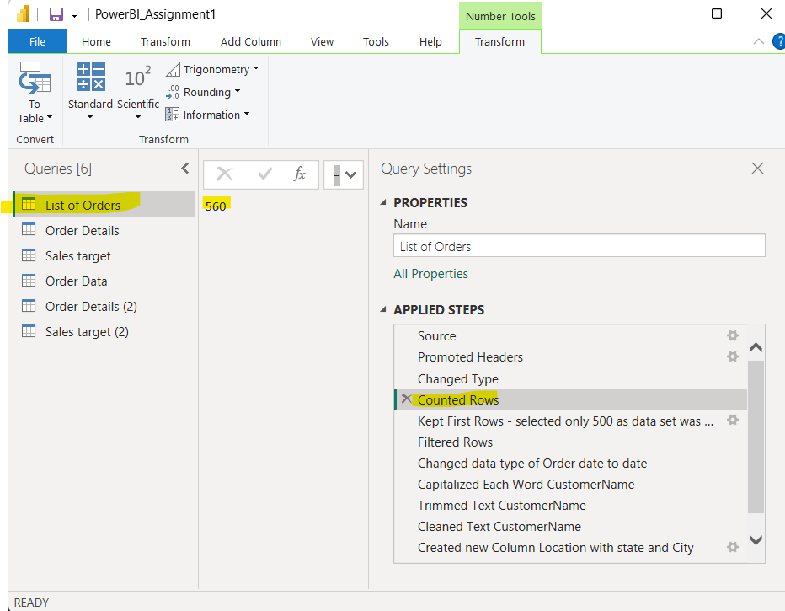
Data set Row Count after restricting to first 500 rows:
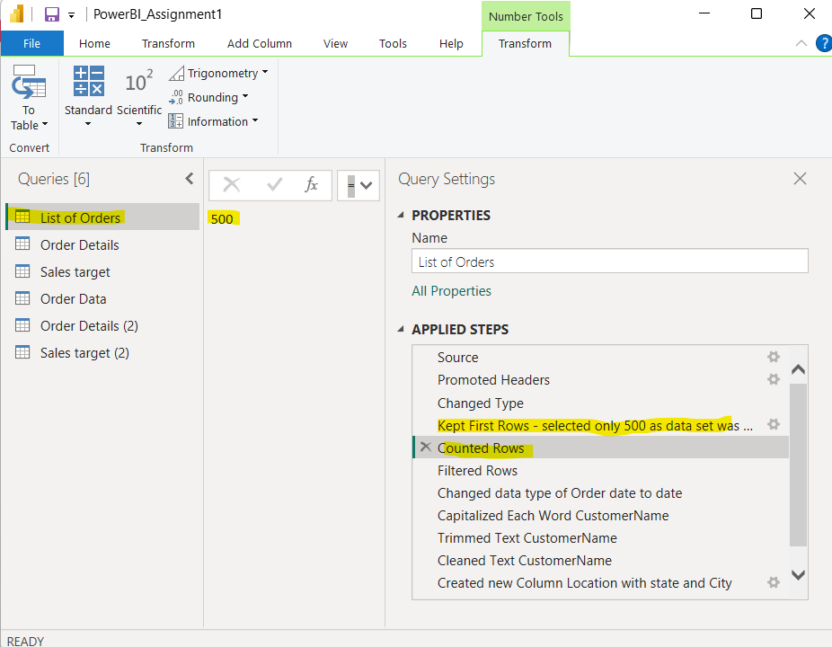
Ensure the “Order Date” column in the “List of Orders” table is set to data type 'Date'.
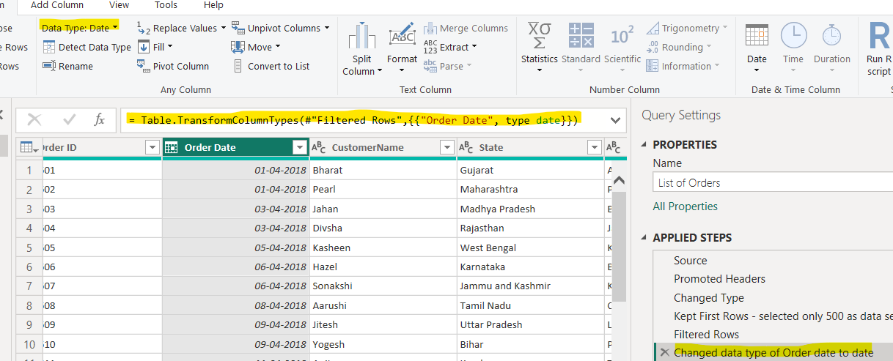

  - Change the data type of “Amount” and “Target” columns to ‘Fixed Decimal Number’.
Amount:
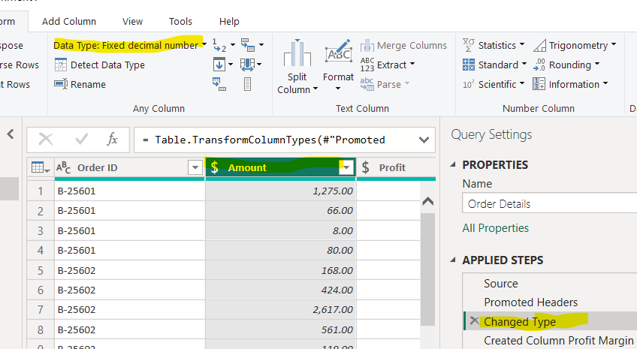
Target:
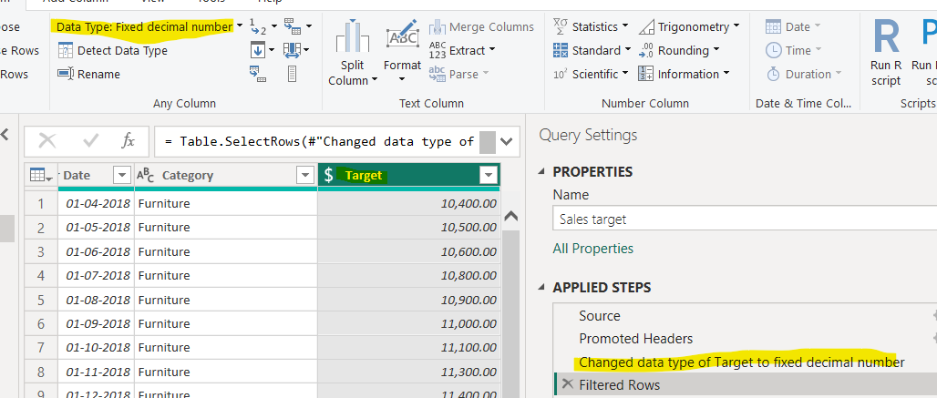
Format the "CustomerName" column into proper case, ensuring consistent capitalization for each word.
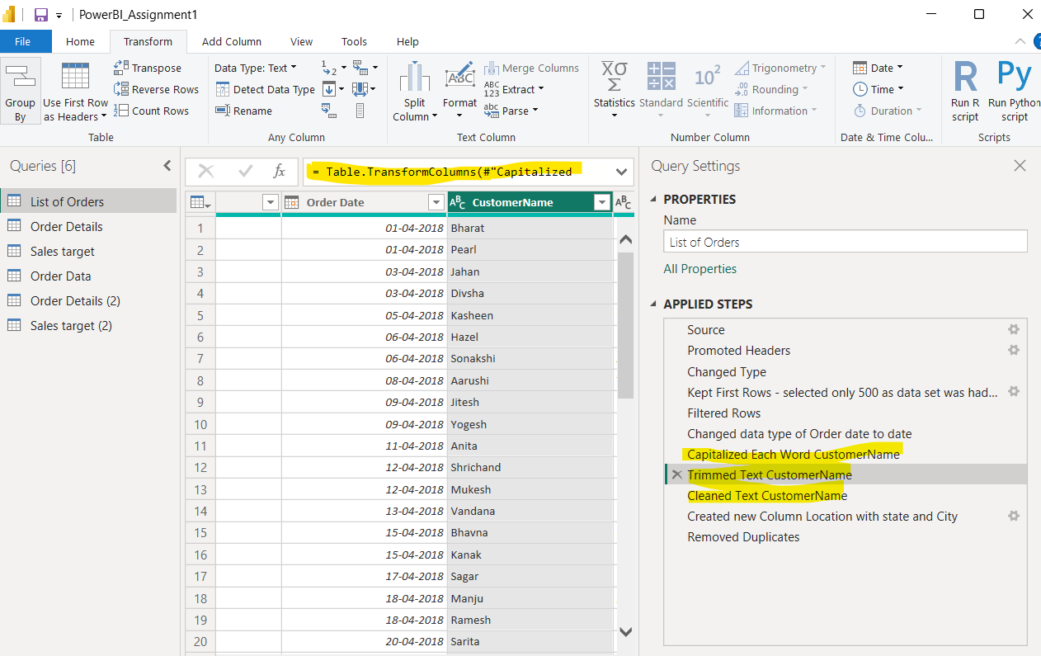

  - Merge the "State" and "City" columns to create a new column named "Location" in the format ‘City, State’.
No Column named Location:
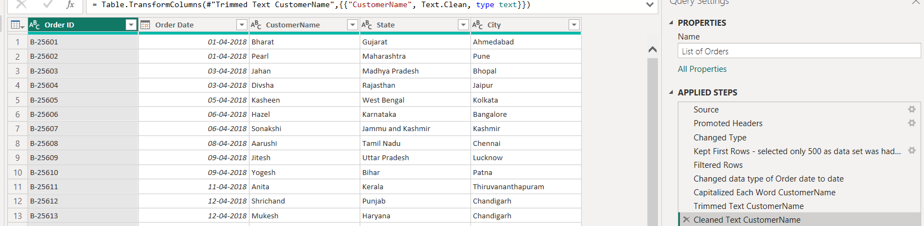
Column Location Created in the format City, State using merge Column:
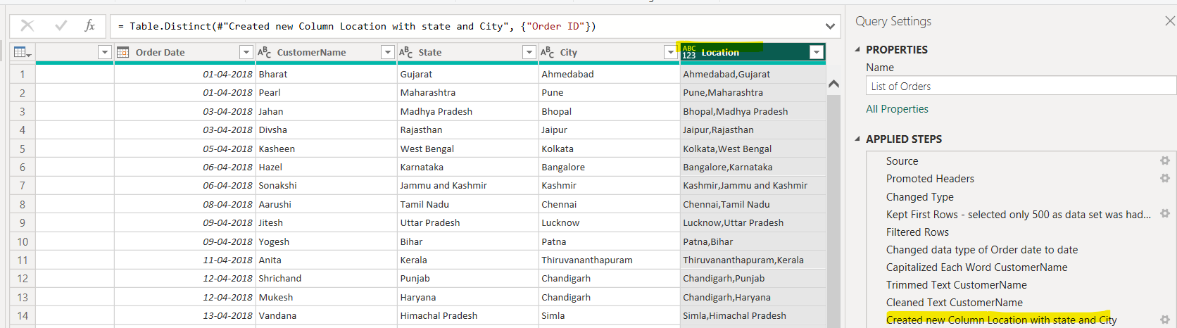
  - Create a new custom column named "Profit Margin" as the percentage of "Profit" divided by "Amount".
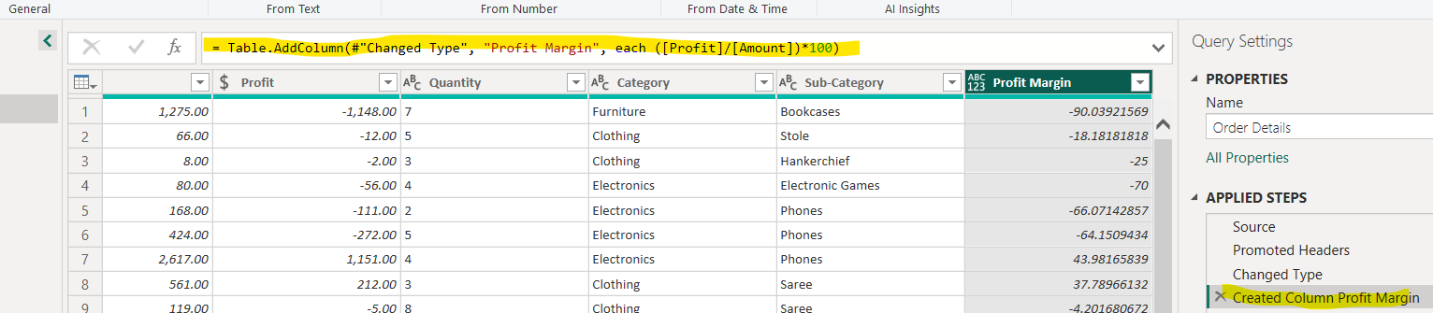
  - Add a new conditional column named "Profit Status" based on the values in the "Profit" column. The conditions are as follows: if the profit is less than 0, the label should be "Loss"; if the profit equals 0, the label should be "Break-Even"; and if the profit is greater than 0, the label should be "Profit".
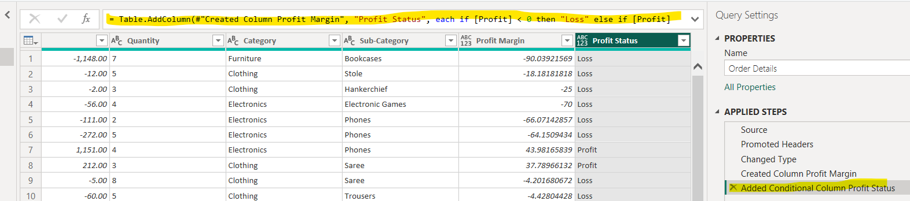

  - Merging Data (Joins): ● Merge the "List of Orders" and "Order Details" tables into a new single table named "Orders Data" based on the "Order ID" relationship.
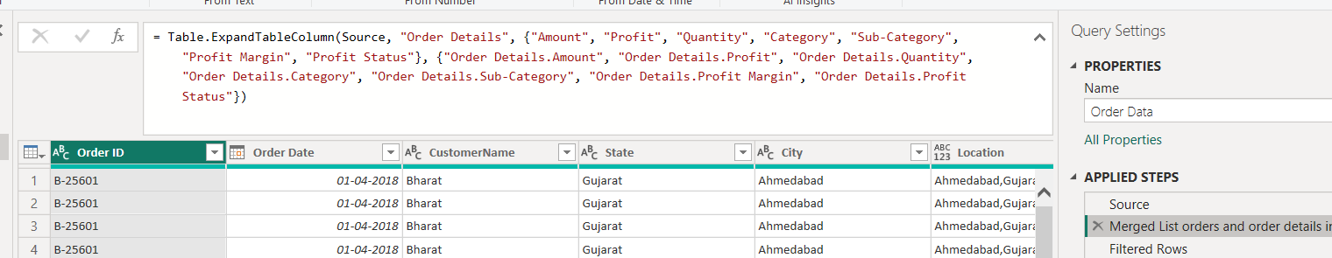

  - Handling Missing Data & Duplicate Data: ● Identify missing values in the data and determine a strategy to address them. ● Check for duplicate rows and define a strategy to handle duplicates.
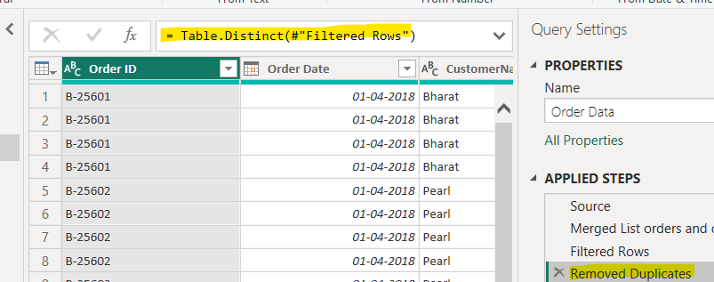

  - Sorting and Filtering Data:
  - Sort the orders by Order Date in descending order to analyse recent trends.
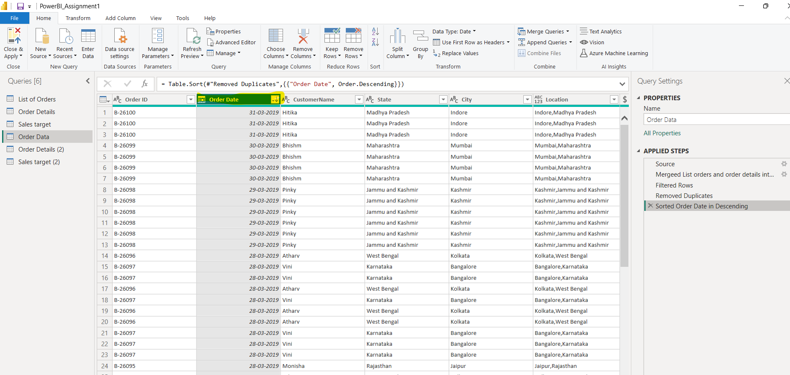

  - Filter the orders to focus only on a specific state (e.g., Tamil Nadu) for regional analysis.
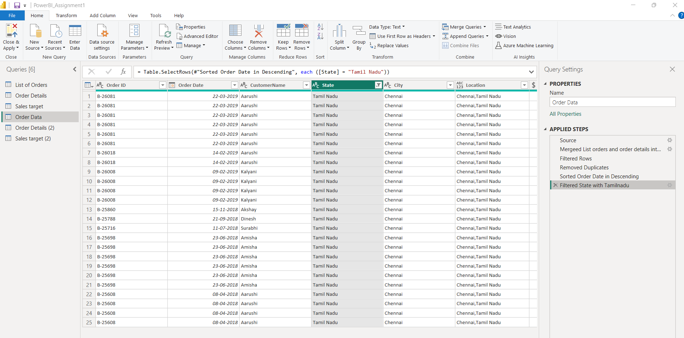

  - Grouping and Aggregating Data:
  - Duplicate the “Order Details” table
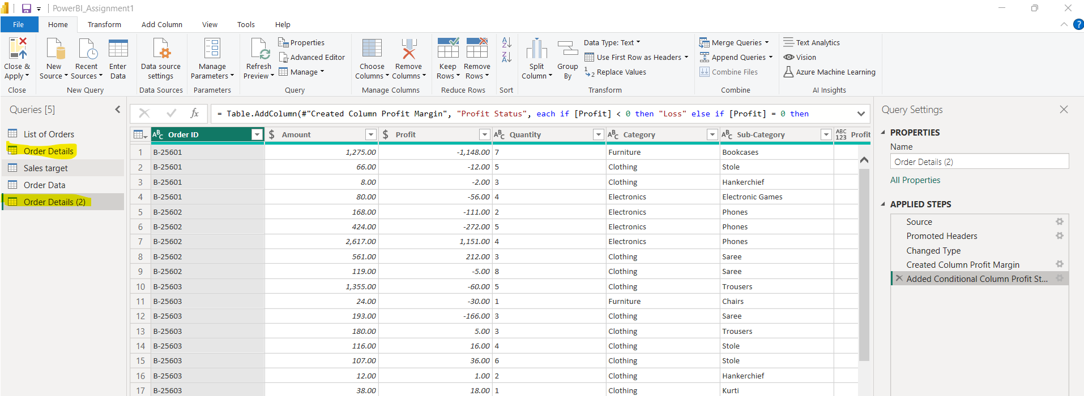

  - The count of each Order ID
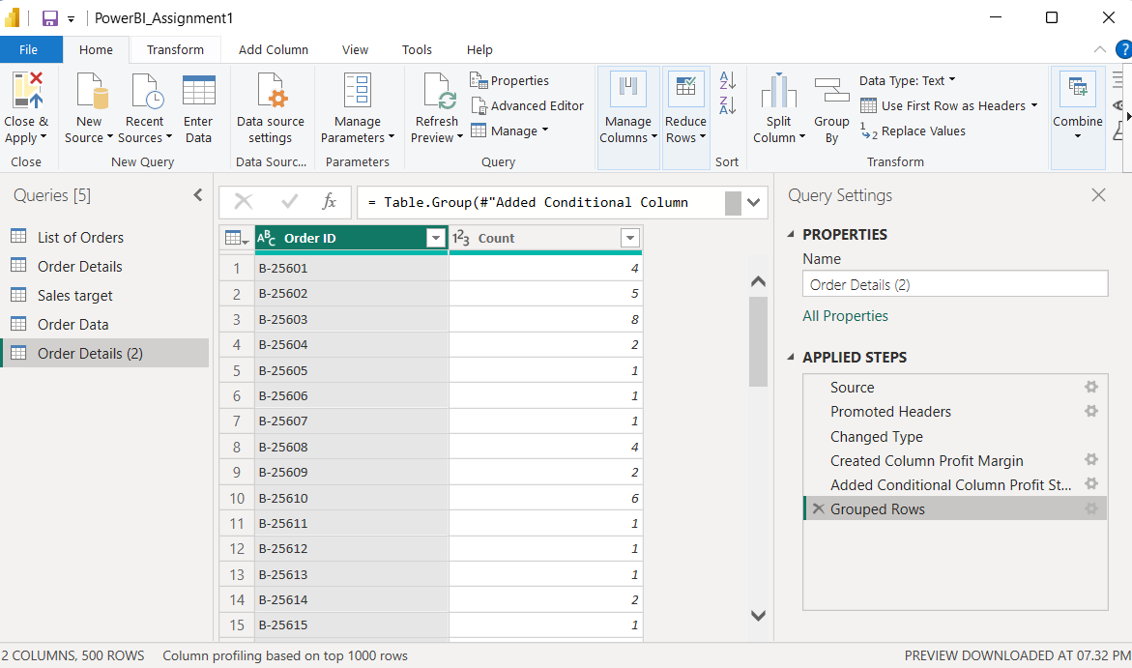

  - Average profit by Category
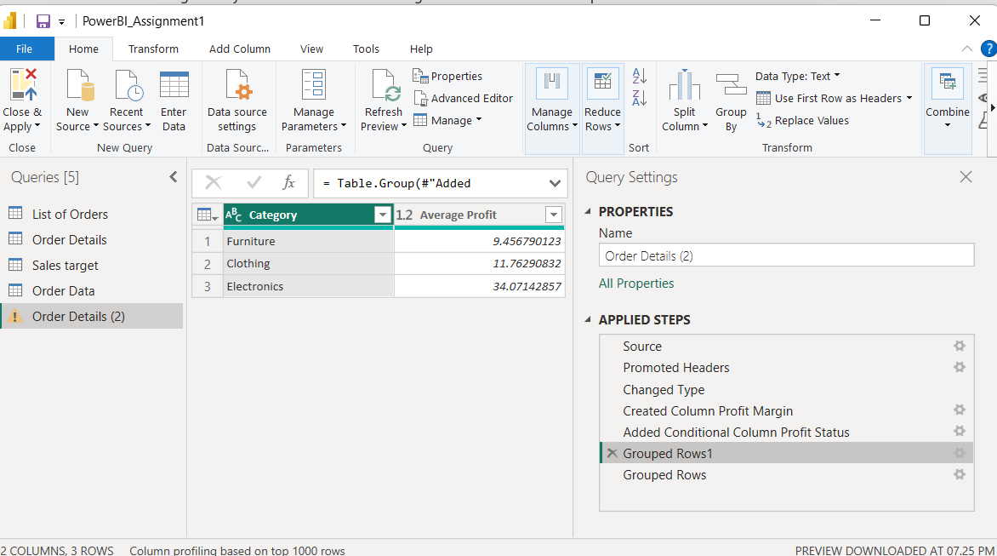

  - Total amount by Sub-Category.
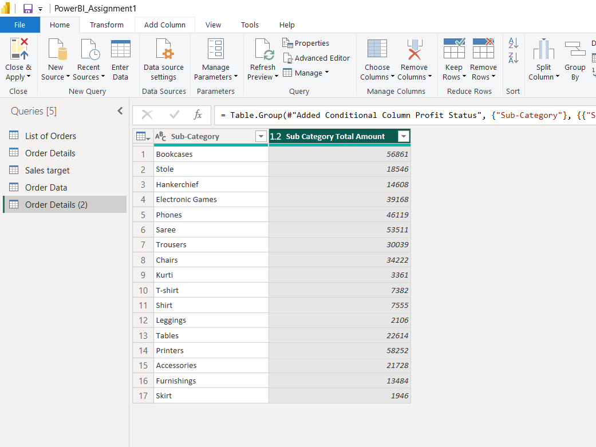
  - Duplicate the “Sales Target” table
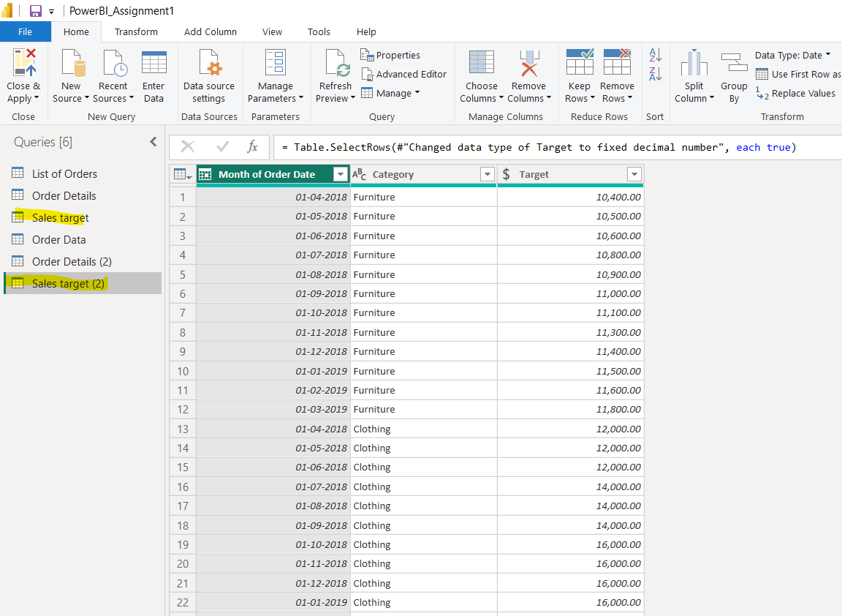

Aggregate the total target amount by Month of Order Date.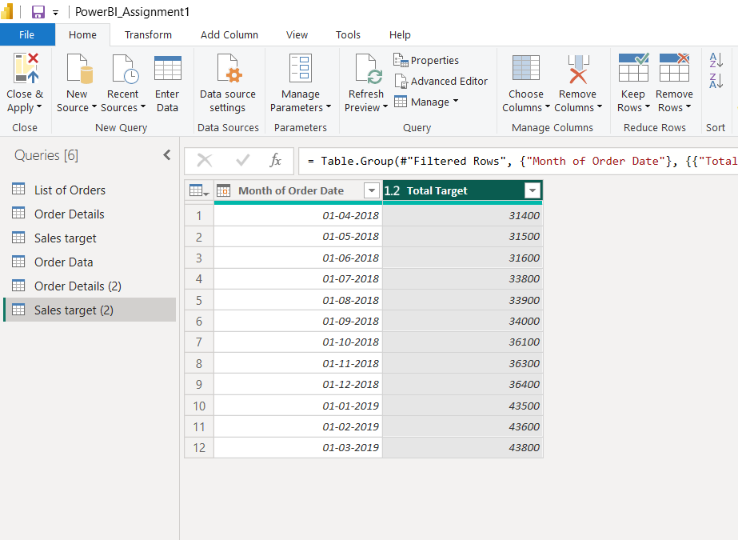

  - Data Modelling:
Relationship between the “List of Orders” and “Order Details” tables using the ‘Order ID’ column.
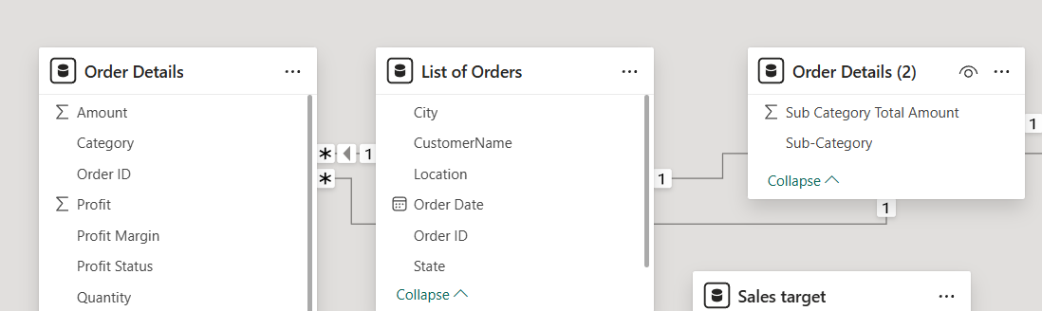

Relationship between the “Order Details” and “Sales Target” tables based on the ‘Category’ column.
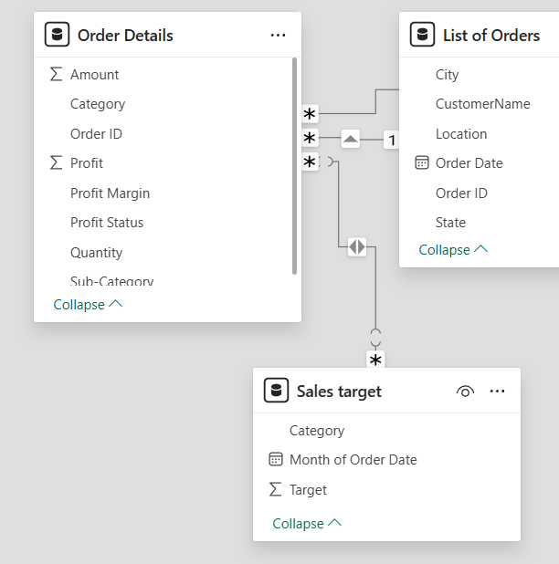

Clicking "Manage relationships" and ensuring this relationship is active.
